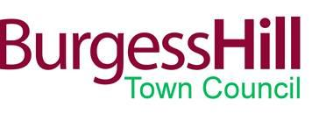

THANK YOU TO OUR COMMUNITY HEROES – AN INVITATION
Dear Ken,

As president of the Burgess Hill District Lions, you have been nominated by the Town Council as one of our Community Heroes for 2020/2021. We are grateful for all the work you have done to support our Burgess Hill community, and want to officially recognize your contribution.

We are inviting a small number of Community Heroes to take part in our Christmas Lights Switch-On, as part of the It’s Christmas in Burgess Hill event. As one of our heroes, if you are able to attend, you would be invited onto the stage in Church Walk, and introduced to the audience with a brief explanation of why you have been nominated, and presented with a certificate of recognition. You would then stay on stage while the lights are switched on by the Town Mayor.

The event will be held on Saturday 20 November, running from 11-5.30, with the lights being switched on at 5pm. We would need you to come to the Town Council Help Point at 4.30pm to assemble and be briefed on the proceedings.
If you are unable to attend, we would like to send you a certificate of recognition, so would appreciate if you could let us know your postal address. This would only be used for this purpose and would not be shared any further, or kept after the certificate is posted.

Kind regards,
Emily Bryant

Emily Bryant
Social Media and Communications Officer
Direct Line : 01444 238206

